Go to www.footytips.com.au or google ESPN footy tips. Then select ‘I want to join a competition’ (rather than login).

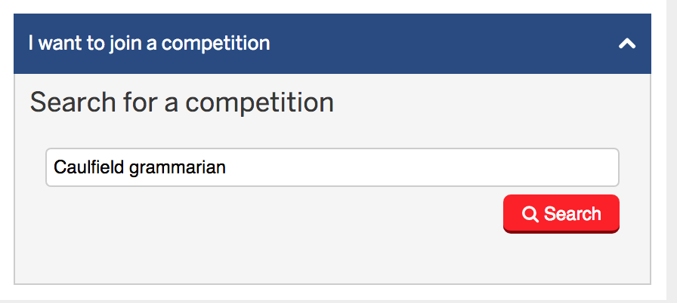
Once you’ve clicked on ‘I want to join a competition’ a drop-down search box will appear. Type in Caulfield grammarians’ and hit search.

The CGA Competition should appear in the search results. Click on the competition name ‘Caulfield Grammarians’ Association’.
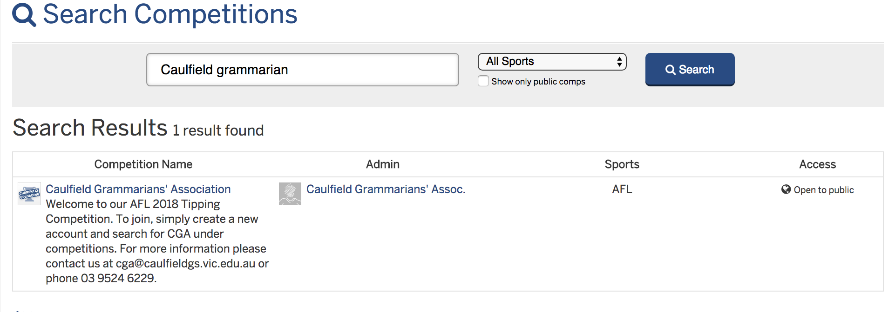

You will get a notice saying ‘You aren’t a member of this competition’. Select ‘Join Comp’.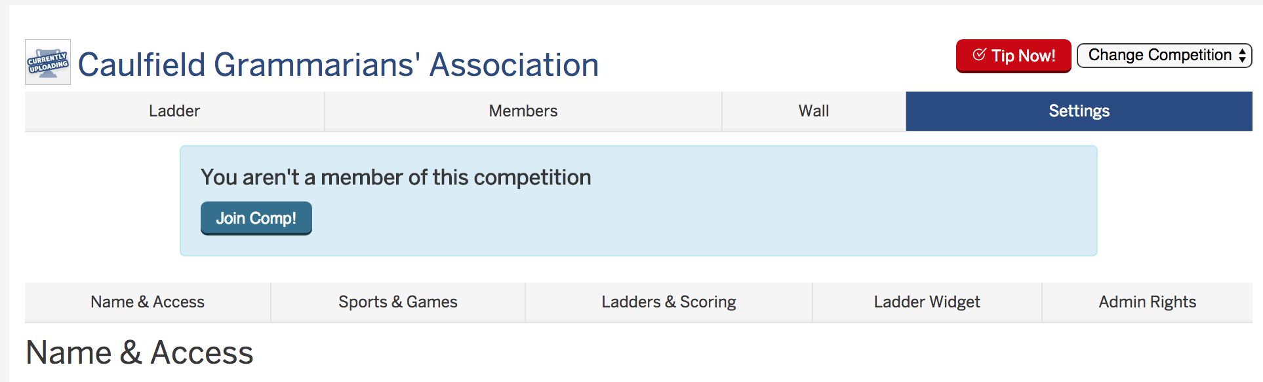
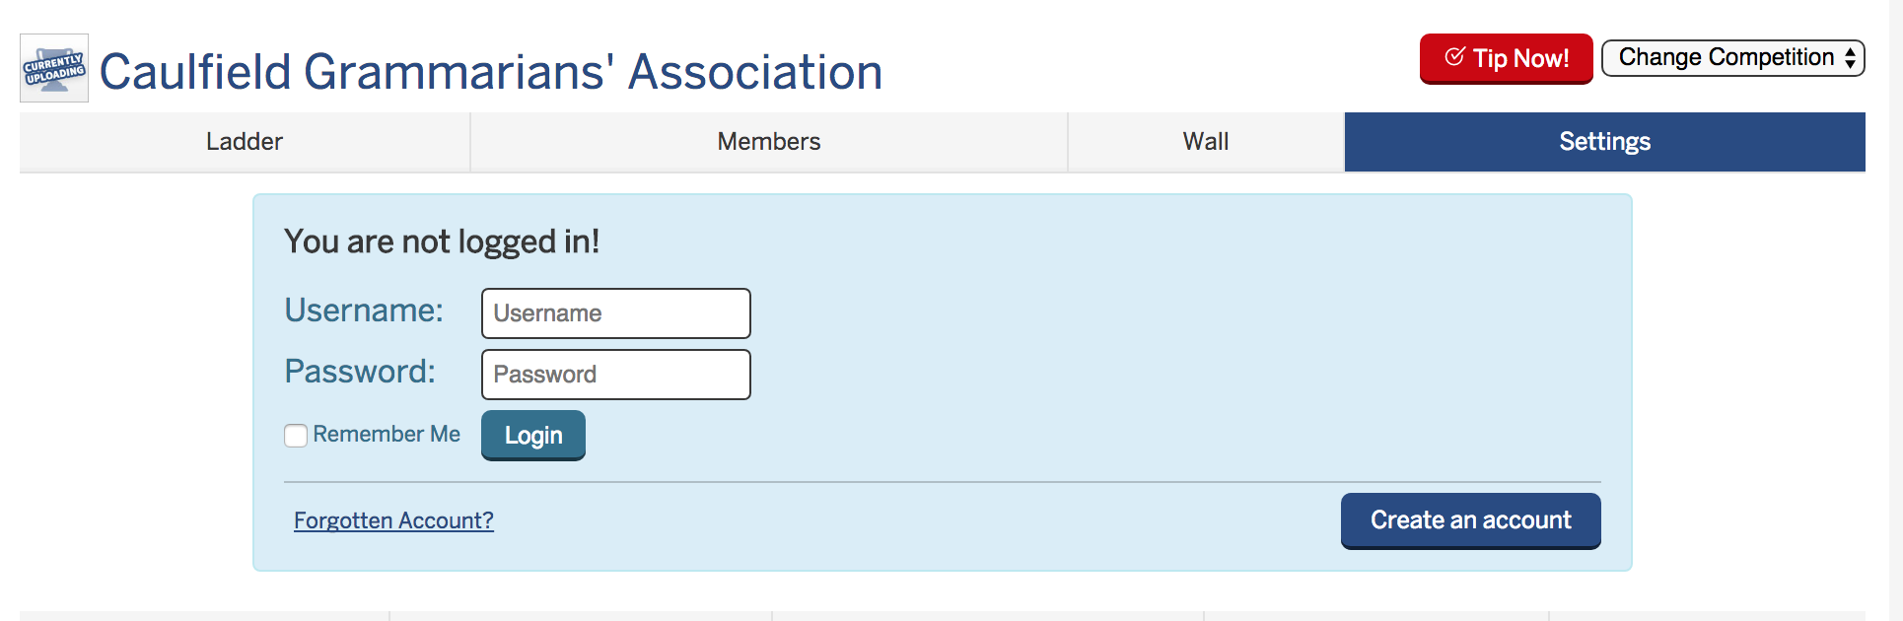
You will see a message saying ‘You are not logged in’. Rather than logging in select ‘create an account’.

Create your account by following the prompts.

