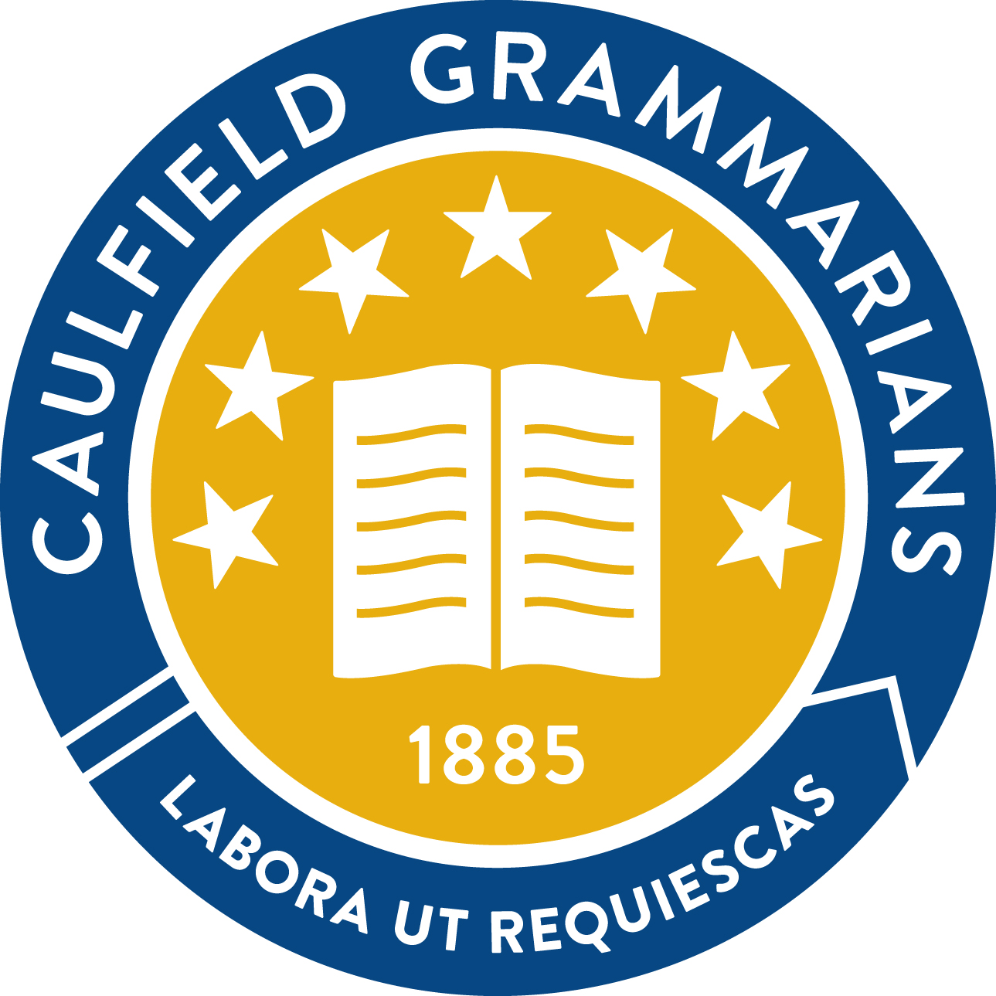

Caulfield Grammarians’ Association

Don Wirth Medal:

Eligibility Criteria & Nomination Form

Last updated: 3 July 2018

Don Wirth Medal Eligibility Criteria

Life Members, Honorary Members and Honorary Life Members may be eligible for nomination for a Don Wirth Medal after completion of 10 years of service to the Association and/or the School (or such lesser period as the CGA Committee may decide in special circumstances).

Length of service alone shall be insufficient to merit an Award. Outstanding service must be the primary foundation upon which an award is granted.

What constitutes outstanding service shall be determined by the CGA Committee from time to time, using the following guidelines (and such other measures as the CGA Committee for the time being may consider relevant and important):
- The nominee will be judged relative to those of similar status.
- The nominee’s contribution is expected to be outstanding relative to his or her peers.
- The nominee’s contribution to the Association or the School must be of a nature that has resulted in a positive change to the life of the Association or the School, in terms of:
- Upholding and pursuing the Association’s objectives; and
- Upholding and pursuing the School’s vision statement in a way which directly or indirectly benefits the Association.

Candidates for a Don Wirth Medal must be nominated, and the nomination must be seconded, by a Life Member, Honorary Member or Honorary Life Member in writing on a form available from the Executive Director. The nomination form is to include a statement pertaining to the candidate’s outstanding service to the Association or the School.

Nominations for a Don Wirth Medal are to be evaluated by the Membership and Awards Committee convened in accordance with Rule 9.4 of the CGA Constitution.

An Award shall only be conferred on the unanimous vote of the CGA Committee based on the recommendation of the Membership and Awards Committee.

Don Wirth Medal Nomination Form

We hereby nominate ______________________________________ for the Don Wirth Medal. This nomination is made based on the rules of the Association, and is supported by the following statement which addresses the requirements of the eligibility criteria:

Nominated by:

_____________________________ (name) _____________________________ (signature)

Seconded by:

_____________________________ (name) _____________________________ (signature)

On completion, please send nomination form, marked “Confidential”, to Executive Director, Caulfield Grammarians’ Association, PO Box 25, Elsternwick Vic 3185, or scan and email to cgaexecutive@caulfieldgs.vic.edu.au.

